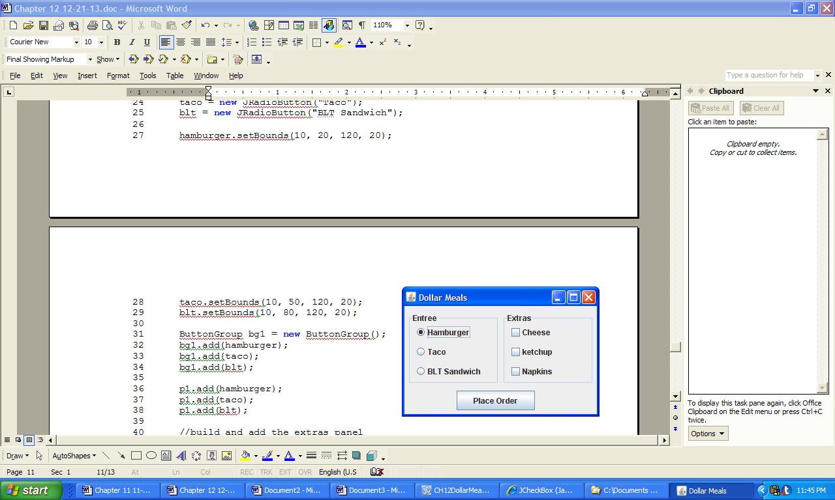 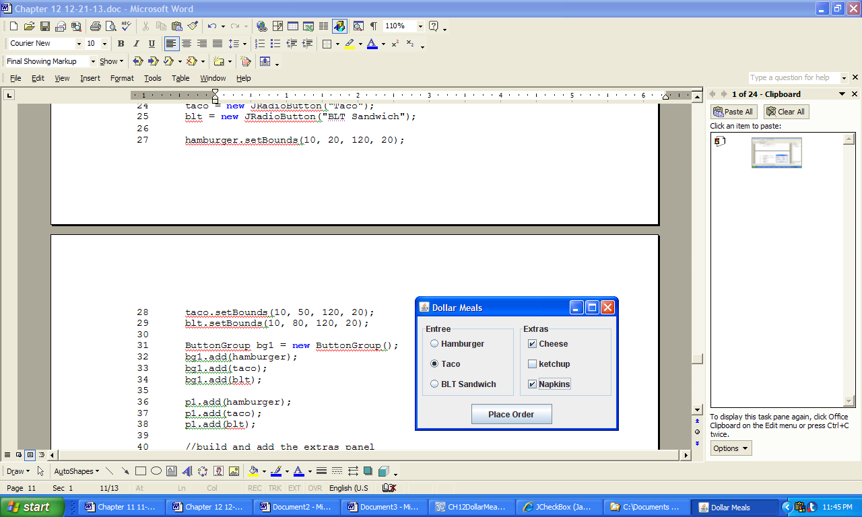

a) b)

*Console output:*

Taco and cheese and napkins

**Figure 12.6 The GUI of the application DollarMeal and a user input and corresponding console output.**